- SYNOPSIS
With the increasing digital footprint of users across various online platforms, understanding and managing personal data has become crucial. This Flutter-based Social media tracker application aims to provide users with a centralized platform to access, review, and manage the data collected by major online services such as Google, Facebook, and Instagram.
The application features a sleek and intuitive UI that categorizes data insights based on different platforms. Users can view their search history, location details, saved passwords, voice search history, and social media activities. Additionally, it offers direct access to download their data stored by these platforms. The app enhances data transparency and empowers users to take control of their digital privacy.
Built with Flutter, the app ensures cross-platform compatibility, a responsive UI, and seamless integration with web views for retrieving data directly from service providers. The project leverages Firebase Authentication for secure access, REST APIs for data fetching, and state management solutions like Provider or River pod for smooth user interactions.
This project is an essential tool for users who wish to stay informed about their online data and privacy settings, making digital transparency more accessible and user-friendly.

2. INTRODUCTION
2.1. Overview of the project
In today’s digital era, individuals generate and interact with vast amounts of personal data across multiple platforms such as Google, Facebook, and Instagram. This data includes search history, location tracking, saved passwords, social media activities, and more. While these platforms provide basic access to personal data, they often lack comprehensive tools for users to efficiently manage, analyze, and secure their information.
The existing system offers limited functionality, with basic interfaces and minimal data management capabilities. Users face challenges such as poor user experience, lack of data visualization, and insufficient security measures. As data privacy and digital security become increasingly important, there is a growing need for an advanced solution that addresses these limitations.
To bridge this gap, the proposed system is a cross-platform mobile application developed using Flutter. This application aims to provide a unified, secure, and user-friendly interface that allows users to view, analyze, and manage their personal data seamlessly. With features such as real-time data visualization, advanced filtering options, secure authentication, and modern UI/UX design, the app will not only enhance the user experience but also ensure robust data security.
The use of Flutter allows for efficient development across both Android and iOS platforms, ensuring high performance and scalability. This project aims to empower users with greater control over their digital footprint while maintaining the highest standards of data privacy and security.

3. SYSTEM ANALYSIS
3.1 Existing System
Overview:
The current system is an application that allows users to view their personal data from platforms like Google, Facebook, and Instagram. It provides insights into account activities such as saved passwords, location history, search history, voice search history, and social media activity.
Existing System Features:
Data Sources:
- Google: Shows saved passwords, location history, search history, account activity, etc.
- Facebook: Displays posts, likes, comments, and account activities.
- Instagram: Provides access to personal data.
UI Design:
- . Tab-based navigation for switching between platforms (Google, Facebook, Instagram).
- Basic clickable links to view specific data.
- Simple static interface with minimal user interaction
Limitations:
- Poor User Experience: Minimal interactive UI, lacks modern design practices.
- Limited Functionality: No advanced filtering, data visualization, or customization options.
- Scalability Issues: Difficult to integrate additional platforms or features easily.
- Security Concerns: No mention of encryption or secure authentication methods.
3.2 Proposed System
Overview:
The proposed system is a cross-platform mobile application developed using Flutter, targeting both Android and iOS platforms. The app will provide enhanced features for users to manage, analyze, and secure their personal data across Google, Facebook, and Instagram.
Key Objectives:
- Improve UI/UX with modern design elements.
- Ensure data security with encrypted storage and secure authentication.
- Add dynamic features like data visualization, filtering, and real-time updates.
- Make the app scalable for future integrations with more platforms.

3.3.Feasibility Study
A feasibility study for this project should consider the following key aspects:

1. Technical Feasibility
Platform: The app appears to be a mobile application with a sidebar menu and social media data retrieval functionality. Consider whether it will be developed for Android, iOS, or both.
Technology Stack: Will it use native development (Kotlin/Swift) or cross-platform frameworks like Flutter or React Native?
Data Sources: The app extracts user data from platforms like Google, Facebook, Instagram, and Twitter. APIs from these services (Google API, Facebook Graph API, Instagram API, Twitter API) will be required.
Security & Privacy: The app must handle sensitive user data securely with encryption and follow GDPR, CCPA, or similar regulations.

2. Economic Feasibility
Development Costs: Includes app development, API access costs, hosting services, and maintenance.
Revenue Model: Will the app be free with ads, subscription-based, or a one-time purchase?
Market Demand: Are users interested in knowing what data social media platforms store about them?

3. Operational Feasibility
User Experience (UX): The app should have an intuitive interface for easy navigation.
API Limitations: Social media platforms may impose restrictions on data access, requiring user authentication and permissions.
Maintenance: Regular updates will be necessary to comply with changing API policies.

4. Legal Feasibility
Compliance: Ensure adherence to privacy laws (GDPR, CCPA).
Platform Policies: Google, Facebook, and other platforms have strict policies on data usage; ensure compliance to avoid legal risks.

5. Market Feasibility
Target Audience: Privacy-conscious users who want to control their data.
Competitor Analysis: Similar apps exist, such as Google’s MyActivity and Facebook’s Download Your Data feature.

4. SYSTEM SPECIFICATION
4.1 Hardware Requirement

CPU Type : Pentium
CPU Clock Speed : 735MHz
RAM : 4GB
Hard Disc Capacity : 100GB
Display Type : VGA
Key Board : 101-102 Enhanced

4.2 Software Requirement

Dart : version 3.103
Flutter : version 3.103
Android Studio : version 1.1
Text Editor : Visual Studio Code
REST APIS : Google, Facebook, Instagram APIs
State Management : Bloc / Provider

4.3. Software Description
4.3.1 An Introduction To Dart
Dart is a versatile, modern, and object-oriented programming language developed by Google. Initially introduced in 2011, Dart was designed to address some of the limitations of JavaScript, with the ultimate goal of offering a better solution for web and mobile application development. Although its initial focus was on web development, Dart has since expanded its use cases, particularly with the rise of Flutter, Google’s framework for building cross-platform mobile apps. Dart enables developers to write clean, maintainable code while providing features that streamline the development process.
Dart’s key feature is its ability to target multiple platforms using a single codebase. This cross-platform nature, combined with a fast, performance-oriented runtime, makes Dart ideal for modern software development, whether you're building for mobile, desktop, or the web. As its popularity continues to grow, understanding Dart has become increasingly relevant for developers who want to stay at the forefront of the rapidly evolving landscape of web and mobile application development.
Overview of Dart
Dart is a general-purpose programming language that emphasizes productivity and performance. It is statically typed, meaning that variable types are explicitly defined, which allows for better error checking at compile time and can lead to more optimized code. At the same time, Dart offers a flexible syntax similar to languages like JavaScript, Java, and C++, which makes it relatively easy for developers with experience in these languages to transition to Dart.
One of Dart’s most distinguishing features is its ability to compile into both Just-in-Time (JIT) and Ahead-of-Time (AOT) machine code. JIT compilation is used during development to quickly iterate and test changes, while AOT compilation is used when deploying applications for production, ensuring maximum performance. The ability to compile to efficient machine code is one of the reasons why Dart is well-suited for building fast, scalable applications.
Dart and the Web
Originally designed as a replacement for JavaScript, Dart has a strong presence in web development. It can run in modern browsers via Dart2js (a tool that compiles Dart code to JavaScript) or directly in browsers that support the Dart VM (Virtual Machine). Dart's syntax is clean, easy to learn, and more predictable compared to JavaScript, which helps reduce the chances of encountering hard-to-debug issues in large codebases.
Dart’s web capabilities extend beyond just the language itself. The language is backed by an extensive ecosystem of libraries and tools. For instance, the Dart web framework, AngularDart, offers a powerful solution for building structured, reactive web applications. Dart also integrates with popular build tools, such as Webpack, and offers built-in support for asynchronous programming, allowing developers to write efficient, non-blocking code.
Dart and Flutter: Revolutionizing Mobile App Development
One of the main reasons Dart has grown so rapidly in popularity is its association with Flutter, a framework developed by Google for creating cross-platform mobile applications. Flutter allows developers to write apps for both iOS and Android using a single Dart codebase, reducing the need to write platform-specific code for each operating system.
The combination of Dart and Flutter offers several advantages. First, Flutter’s widget-based UI design is highly customizable, allowing for beautiful, expressive, and responsive user interfaces. Dart’s performance is another key factor: apps written with Dart and Flutter are compiled into native ARM code, which results in faster performance than JavaScript-based solutions. Additionally, because Dart is an object-oriented language, it’s easy to create modular, reusable components that can speed up development and improve maintainability.
Furthermore, Flutter and Dart work together seamlessly to deliver a smooth developer experience. With hot reload, developers can see their changes immediately, allowing for faster iteration and testing. This feature is highly beneficial for mobile app development, where frequent adjustments to the user interface and behavior are common.

Key Features of Dart
1. Strong Typing
Dart is statically typed, meaning variable types must be defined at compile time. This feature allows for early detection of errors, making it easier to catch bugs before they manifest at runtime. While this makes the development process more rigorous, it also enhances code readability, maintainability, and performance. Dart allows developers to use both dynamic types and strongly typed variables, giving flexibility without sacrificing safety.
2. Object-Oriented Programming
Dart is an object-oriented language, supporting core principles such as classes, inheritance, and polymorphism. Everything in Dart is an object, including numbers, functions, and even null. This simplifies the language and allows developers to structure their code in a logical, modular way.
3. Asynchronous Programming
Dart has built-in support for asynchronous programming with features like Future and Stream. Asynchronous programming is essential for writing non-blocking code, which is particularly useful for tasks like I/O operations, network requests, and updating UI elements without freezing the application. Dart’s async and await keywords make it easy to work with asynchronous code in a way that is both readable and efficient.

4. Garbage Collection
Dart has automatic garbage collection, which simplifies memory management for developers. The garbage collector reclaims memory that is no longer in use, ensuring that applications remain efficient and free from memory leaks. This feature is particularly important for large, complex applications that run over extended periods of time.

5. Rich Library Ecosystem
Dart comes with a comprehensive set of core libraries that make it easy to develop both simple and complex applications. From basic data structures to advanced networking and file I/O, Dart’s libraries cover a wide range of functionality. Additionally, the Dart community has developed a wealth of open-source packages and tools available through the package manager, Pub, which further extends Dart’s capabilities.
Dart for Desktop Applications
Though initially focused on web and mobile, Dart can also be used to build desktop applications. With the help of frameworks such as Flutter for Desktop, Dart developers can create cross-platform desktop applications for Windows, macOS, and Linux. This allows developers to extend the reach of their applications beyond mobile and the web, providing even more versatility and opportunities for creating user-facing solutions across devices.
Advantages of Dart
- Fast Development Cycle: With features like JIT compilation, hot reload, and easy debugging, Dart allows developers to rapidly prototype, test, and deploy applications. This improves developer productivity and leads to faster time-to-market for applications.
- Strong Ecosystem and Community: Dart's growing ecosystem, along with strong community support, provides developers with plenty of resources and tools for tackling a wide range of development challenges. Whether you are building for the web, mobile, or desktop, Dart's ecosystem offers libraries and frameworks tailored to your needs.
- Cross-Platform Development: Dart’s integration with Flutter for mobile and web development reduces the need for developers to learn multiple languages and frameworks for different platforms. A single codebase can be used to target multiple platforms, saving time and resources.
- Performance: Dart's ability to compile to native machine code (AOT) ensures high performance, especially for mobile and desktop applications. This makes Dart a competitive alternative to other languages commonly used in application development.

Example:
void main() {
print('Hello, World!');
}

4.3.2 An Introduction To Flutter
In today’s fast-paced world, the demand for mobile applications is ever-growing. Developers face the challenge of delivering high-performance, visually appealing apps for multiple platforms without duplicating effort. This is where Flutter comes in—an open-source framework created by Google that enables developers to build natively compiled applications for mobile, web, and desktop from a single codebase. Flutter has gained tremendous popularity due to its ease of use, rich set of widgets, and the ability to create high-performance applications across multiple platforms. This introduction explores what Flutter is, its architecture, key features, and how it enables developers to create beautiful, fast, and cross-platform applications.
What is Flutter?
Flutter is a UI toolkit that helps developers create natively compiled applications for mobile (iOS and Android), web, and desktop (Windows, macOS, Linux) from a single codebase. It was initially released by Google in May 2017, and since then, it has rapidly gained adoption among developers due to its powerful features and flexibility.
The core concept of Flutter is its "widget-based" approach to building UIs. Everything in Flutter is a widget—buttons, text, images, layouts, and even the entire app interface. This allows for a highly customizable, flexible, and extensible user interface that is both intuitive and efficient to work with. Flutter offers a vast set of pre-designed widgets, making it easy to create visually rich and responsive applications.
The real power of Flutter lies in its "write once, run anywhere" philosophy. With Flutter, developers no longer need to maintain separate codebases for iOS, Android, and other platforms. This not only speeds up development but also reduces the cost and complexity of managing multiple platforms. By writing the application once, it can run seamlessly across different devices without sacrificing performance or native-like experience.
Architecture of Flutter
Flutter’s architecture is built around a few key components that make it unique and efficient for building cross-platform applications:
- Dart Programming Language: Flutter uses Dart, a statically typed language developed by Google. Dart is known for its fast compilation and easy-to-learn syntax. It works seamlessly with Flutter, enabling quick development cycles, including "hot reload" functionality, which speeds up the iteration process during development. Dart is also highly efficient in terms of performance, making it suitable for both high-end mobile applications and complex UI rendering.
- Widgets: The building blocks of any Flutter application are widgets. Everything you see on the screen in a Flutter app—such as buttons, text fields, containers, and even entire screens—is a widget. Flutter's widgets are designed to be highly customizable, allowing you to compose your user interface in a way that meets the exact needs of your app. There are two main types of widgets in Flutter:
  - Stateless Widgets: These widgets do not hold any state (data that changes over time). Examples include a simple button or an icon.
  - Stateful Widgets: These widgets have mutable state, meaning they can change based on user interactions or other events, such as updating the UI when a user taps a button or enters text.
- Flutter Engine: The Flutter engine is responsible for rendering the UI and interacting with the underlying platform. It uses Skia, a high-performance 2D graphics library, to render graphics. This allows Flutter to provide smooth animations and high-quality visuals. The engine also handles platform-specific code via the Platform Channels, which allow Flutter to communicate with native code written in Java, Kotlin (for Android), Objective-C, or Swift (for iOS).
- Flutter Framework: The Flutter framework provides a rich set of pre-built, customizable widgets that can be used to design the user interface. It also includes libraries for handling gestures, navigation, networking, animations, and more. The framework ensures that your app runs consistently across all platforms.
- Platform-Specific Integration: While Flutter provides a unified development experience, it also allows developers to access platform-specific APIs when needed. This is achieved through platform channels, which enable communication between Flutter code and native platform code. This means that if an app requires features unique to iOS or Android, such as using device sensors, interacting with native SDKs, or implementing platform-specific UI elements, Flutter can bridge the gap without affecting the overall cross-platform nature of the app.
Key Features of Flutter
Flutter has several standout features that make it a powerful tool for developers. These include:
1. Hot Reload
Hot reload is one of Flutter’s most celebrated features. It allows developers to see the changes they make in the code instantly reflected in the app, without having to restart the entire application. This significantly speeds up the development process, as developers can quickly iterate on their designs and fix issues without waiting for the app to reload completely. It makes the development process feel much more dynamic and intuitive.
2. Single Codebase for Multiple Platforms
One of the biggest advantages of Flutter is its ability to use a single codebase for applications across multiple platforms. Flutter supports iOS, Android, web, and desktop platforms (Windows, macOS, Linux). This reduces the complexity of maintaining separate codebases for different platforms and minimizes development costs. As a result, developers can focus on creating a great app instead of managing platform-specific concerns.

3. Rich Set of Widgets and Customization
Flutter provides a large number of pre-built widgets that follow the Material Design (for Android) and Cupertino (for iOS) guidelines, ensuring that apps look and feel native to the platform. These widgets are highly customizable, so developers can tweak them to match their app's unique design needs. Flutter's flexibility enables developers to create sophisticated UIs with smooth animations and effects that enhance user experience.
4. Performance
Flutter offers near-native performance because it compiles directly to native ARM code. This means that Flutter apps are not running on a webview or interpreted code but are compiled to native code, making them fast and efficient. The Flutter engine uses Skia graphics rendering, which allows for smooth graphics and animations, even in demanding applications.
5. Extensive Ecosystem and Plugins
Flutter's ecosystem includes a growing collection of packages and plugins available via the pub.dev repository. These packages extend Flutter’s capabilities by providing solutions for integrating with APIs, databases, authentication systems, and more. For example, developers can use packages for Firebase, Google Maps, camera integration, and payment gateways. If a particular feature or library doesn’t already exist, developers can easily create their own platform channels to interact with native APIs.
6. Expressive and Customizable UI
Flutter is known for its beautiful and expressive UIs. Developers can easily create custom designs that can mimic complex animations, transitions, and behaviors. With Flutter, there’s no need to rely on the native UI components of the platform, which means that developers can break free from platform limitations and create fully customized interfaces that are both engaging and interactive.

7. Community and Support
Since its release, Flutter has grown rapidly in terms of both usage and community support. The Flutter community is vibrant and constantly contributing to the ecosystem with new packages, tools, and resources. Google and the broader community regularly update Flutter, adding new features, fixing bugs, and improving documentation. The community provides a wealth of tutorials, forums, and open-source projects that help developers learn and solve problems efficiently.
Advantages of Flutter
- Cross-Platform Development: Flutter allows developers to write one codebase that runs on both Android and iOS (as well as other platforms). This results in significant time and cost savings compared to building separate applications for each platform.
- Faster Development and Testing: With features like hot reload, Flutter drastically reduces the time developers spend writing and testing code. The ability to see real-time changes in the app speeds up the iteration process, improving productivity.
- Native-Like Performance: Flutter’s direct compilation to native code ensures that applications perform well even with complex UI components, making it ideal for high-performance mobile applications.
- Strong Support for Modern App Features: Whether it’s integrating APIs, creating smooth animations, or building custom widgets, Flutter supports the latest development features, which makes it an excellent choice for modern app development.
- Unified Experience Across Platforms: Flutter apps maintain a consistent experience across multiple platforms, ensuring that users have the same look, feel, and functionality, regardless of the device they are using.

Example: Simple button press app
import 'package:flutter/material.dart';
void main() {
runApp(MyApp());
}
class MyApp extends StatelessWidget {
@override
Widget build(BuildContext context) {
return MaterialApp(
title: 'Flutter Button Press Example',
theme: ThemeData(
primarySwatch: Colors.blue,
),
home: MyHomePage(),
);
}
}
class MyHomePage extends StatefulWidget {
@override
_MyHomePageState createState() => _MyHomePageState();
}
class _MyHomePageState extends State<MyHomePage> {
String _message = 'Hello, Flutter!';
// Method to change the message when the button is pressed
void _changeMessage() {
setState(() {
_message = 'You pressed the button!';
});
}
@override
Widget build(BuildContext context) {
return Scaffold(
appBar: AppBar(
title: Text('Flutter Button Press Example'),
),
body: Center(
child: Column(
mainAxisAlignment: MainAxisAlignment.center,
children: <Widget>[
// Display the current message
Text(
_message,
style: TextStyle(fontSize: 24, fontWeight: FontWeight.bold),
),
SizedBox(height: 20), // Spacer
// Button that changes the message
ElevatedButton(
onPressed: _changeMessage,
child: Text('Press Me'),
style: ElevatedButton.styleFrom(
primary: Colors.blue, // Button color
padding: EdgeInsets.symmetric(horizontal: 20, vertical: 10),
textStyle: TextStyle(fontSize: 18),
),
),
],
),
),
);
}
}

4.3.3 An Introduction To API
An API (Application Programming Interface) is a set of rules and protocols that allow different software applications to communicate with each other. APIs define the methods and data formats that applications use to request and exchange information. In simple terms, an API acts as a bridge between different systems, enabling them to work together.
For example, when you use a mobile app to check the weather, the app communicates with a weather service's API to fetch the latest data. Similarly, when you use a social media app to post a photo, the app interacts with the platform's API to upload the image.
APIs are essential for modern software development because they enable different services, applications, or platforms to integrate and function seamlessly, whether it's for retrieving data, sending information, or performing other tasks.
Types of APIs:
- Web APIs: These APIs allow communication between a web server and a client (usually a web browser or mobile app) over the internet, typically using HTTP. Examples include RESTful APIs and SOAP APIs.
- Library APIs: These provide access to a set of functions or routines packaged into libraries, allowing developers to use specific features without having to write everything from scratch.
- Operating System APIs: These define how applications interact with the underlying hardware and software of an operating system (e.g., Windows or macOS).
- Database APIs: These allow applications to interact with databases, querying and manipulating data.
Benefits of Using APIs:
- Efficiency: APIs allow developers to use existing services or functionalities, saving time and effort.
- Interoperability: APIs enable different platforms and technologies to work together.
- Scalability: APIs make it easier to integrate new features into existing systems without major changes.
- Innovation: By accessing various third-party APIs, developers can build on top of existing solutions, enabling faster development of new applications.

4.3.4 REST API
A REST API (Representational State Transfer Application Programming Interface) is a set of web services that follows the principles of REST architecture. REST is an architectural style for designing networked applications, and REST APIs are widely used for building web services that can interact over HTTP. REST APIs allow different systems, applications, or services to communicate and exchange data in a lightweight, scalable, and stateless way.
Key Principles of REST:
- Statelessness: Each request from a client to the server must contain all the information needed to understand and process the request. The server does not store any session state between requests. This makes REST APIs scalable and easy to maintain.
- Client-Server Architecture: REST follows the client-server model, where the client (usually a browser or mobile app) and the server (which hosts the data or application logic) are separate. This separation allows each to evolve independently.
- Uniform Interface: REST APIs have a consistent and standardized interface that makes them easy to understand and use. This means that the same set of rules applies to all RESTful interactions.
- Resource-Based: In REST, data and services are represented as "resources" (e.g., users, products, orders). Each resource is identified by a unique URL (Uniform Resource Locator). Resources are manipulated using standard HTTP methods.
- Use of HTTP Methods: REST APIs primarily use the following HTTP methods to perform operations on resources:
  - GET: Retrieve a resource or a collection of resources (read operation).
  - POST: Create a new resource (create operation).
  - PUT: Update an existing resource (update operation).
  - DELETE: Remove a resource (delete operation).
- Representation: The client interacts with the resource via its representation (usually in JSON or XML format). For example, when a client requests data about a product, the server may return the product's details in JSON format.
- Stateless Communication: Each HTTP request is independent and contains all the data needed for processing. The server does not maintain any session information between requests.
Example of REST API:
Let's say you have a REST API for managing users in an application. Here's how various HTTP methods would be used to interact with the /users resource:
- GET /users: Retrieves a list of all users.
- GET /users/123: Retrieves information about the user with ID 123.
- POST /users: Creates a new user (the client would send the user data in the request body).
- PUT /users/123: Updates the information of the user with ID 123.
- DELETE /users/123: Deletes the user with ID 123.
Advantages of REST APIs:
- Scalability: Because REST APIs are stateless and follow a client-server architecture, they can easily scale to handle large numbers of requests and users.
- Simplicity: REST APIs are easy to understand and implement, using standard HTTP methods and status codes.
- Flexibility: REST APIs can handle different types of data formats (e.g., JSON, XML, etc.) and can be used across different platforms.
- Cacheable: Responses from REST APIs can be cached to improve performance and reduce server load.
Example of a REST API Request and Response:
Here’s a simple example of a GET request to retrieve a user profile.
Request(http):
GET /users/123 HTTP/1.1
Host: api.example.com
Authorization: Bearer <access_token>
Response (JSON):
{
"id": 123,
"name": "John Doe",
"email": "john.doe@example.com",
"age": 30
}
In this example:
- The GET request retrieves the details of the user with ID 123.
- The response is in JSON format, containing the user’s data.

1. Google API (Google Sign-In and other services)
Google Sign-In is a common way to authenticate users in your app, and Google offers a variety of services (like Google Drive, Calendar, Gmail) via APIs.

2. Facebook API (Facebook Login)
To integrate Facebook login, you'll use the flutter_facebook_auth package. Facebook allows you to authenticate users and access basic profile information.

3. Instagram API (Instagram Graph API)
Instagram’s API is a part of the Facebook Graph API, and you typically use the Instagram Basic Display API for authentication and accessing user profiles and media. Note that Instagram Graph API is more geared toward business accounts, so for personal use, you may need Instagram’s Basic Display API.

4.3.5 An Introduction To Gradle
Gradle is a powerful, open-source build automation tool that is widely used for building, testing, and deploying software. It was designed to automate the process of building and managing software projects, particularly for Java, Kotlin, and Android development, though it can also be used for a wide range of other programming languages and platforms.
Gradle uses a domain-specific language (DSL) based on Groovy or Kotlin to define the build logic. This flexibility makes it a highly customizable tool for developers, allowing them to define complex build processes in a simple, declarative way.
Key Features of Gradle
- Flexibility and Customizability: Gradle is highly customizable, allowing developers to define and manage complex build processes using Groovy or Kotlin DSLs. You can easily define custom tasks, plugins, and workflows suited to your project’s needs.
- Multi-Project Builds: Gradle excels at managing large projects that consist of multiple modules or components. It provides features for building and managing dependencies between different parts of a project, making it ideal for enterprise-level and multi-module projects.
- Performance: Gradle is known for its performance, particularly for large projects. It uses techniques like incremental builds and build caching to avoid redundant work. Only the tasks that have changed are re-executed, which significantly speeds up build times. Gradle can also parallelize tasks to maximize CPU utilization and further reduce build time.
- Dependency Management: Gradle provides an integrated and flexible way to manage dependencies. You can easily declare external libraries and frameworks for your project, and Gradle will download and manage them automatically. It also supports both Maven and Ivy repositories for dependency resolution.
- Build Scripts: Gradle build scripts are written in either Groovy or Kotlin, making them easy to read and write. These scripts define the tasks and configurations required to build your project.
- Multi-Language Support: While Gradle is predominantly used in Java and Android development, it also supports a wide variety of languages such as C/C++, JavaScript, Python, and Groovy, allowing it to be used for a range of different software development projects.
- Integration with IDEs: Gradle integrates smoothly with popular Integrated Development Environments (IDEs) like IntelliJ IDEA, Eclipse, and Android Studio. These integrations simplify the process of managing builds directly from within the IDE, enhancing the developer experience.
- Plugin Ecosystem: Gradle supports a rich ecosystem of plugins that extend its functionality. Some popular plugins include those for Java, Android, Kotlin, and Scala, as well as plugins for tasks like code quality checks, versioning, and deployment.
How Gradle Works
Gradle’s build process revolves around the concept of tasks. A task represents a unit of work, such as compiling code, running tests, or packaging an application. Tasks can be grouped into logical sequences, and Gradle ensures that they are executed in the correct order.
- Build Script: The build process is controlled by a build script (build.gradle for Groovy or build.gradle.kts for Kotlin), where you define tasks, configurations, and dependencies.
- Tasks: A task can be a simple command like "compile" or "test," or it could be more complex, such as deploying an application to a server. Gradle provides lifecycle tasks such as build, clean, and assemble.
- Dependencies: Gradle uses a dependency management system to manage libraries, plugins, and tools that your project depends on. Dependencies are typically fetched from online repositories like Maven Central or JCenter.
Gradle vs. Other Build Tools
Gradle is often compared to other popular build tools like Maven and Ant, and each has its strengths and use cases. Here's how Gradle compares:
- Gradle vs. Maven:
  - Ease of Use: Gradle is generally more flexible and easier to use, with a DSL that is concise and allows for better customization. Maven uses XML, which can become cumbersome and less readable for complex configurations.
  - Performance: Gradle’s incremental builds and build caching make it faster than Maven, especially for large projects.
  - Dependency Management: While Maven has powerful dependency management, Gradle’s system is more flexible and supports more repositories out of the box.
- Gradle vs. Ant:
  - Flexibility: Ant is a procedural build tool that allows fine-grained control but can become complex for large projects. Gradle, on the other hand, uses a more declarative style, making it easier to manage complex builds with less code.
  - Dependency Management: Ant lacks built-in dependency management (though it can be added with Apache Ivy), while Gradle has native support for dependency resolution.
Key Components in the Example:
- apply plugin: Specifies the plugin to use for the build (in this case, the Java plugin).
- repositories: Declares repositories like Maven Central to fetch dependencies from.
- dependencies: Specifies the external libraries (e.g., Spring Core and JUnit in the example).
- task: Defines a custom task that can be executed (in this case, a run task that runs a Java application).
Gradle in Android Development
Gradle is the official build system for Android development. Android Studio uses Gradle as its default build system, which provides several advantages, including:
- Gradle-based build files (build.gradle), which allow developers to define custom build configurations, product flavors, build variants, and dependencies for their Android apps.
- Multi-module support for large Android projects, where different parts of the project can be built separately.
- Dependency management for Android libraries and third-party dependencies through repositories like Maven Central and JCenter.
- Customizable build types: Developers can define different build types (e.g., debug and release) and product flavors (e.g., free vs. paid versions of an app) using Gradle.

- SYSTEM DESIGN
5.1 Project Structure:

/social_media_dashboard
├── lib/
│ ├── main.dart
│ ├── screens/
│ │ ├── home_screen.dart
│ │ ├── google_screen.dart
│ │ ├── facebook_screen.dart
│ │ ├── instagram_screen.dart
│ │ ├── twitter_screen.dart
│ ├── widgets/
│ │ ├── side_menu.dart
│ │ ├── social_card.dart
├── assets/
│ ├── google_logo.png
│ ├── facebook_logo.png
│ ├── instagram_logo.png
│ ├── twitter_logo.png
├── pubspec.yaml

5.2 Project Dependencies:
name: socialmedia_data_privacy
description: "A new Flutter project."
publish_to: 'none' # Remove this line if you wish to publish to pub.dev

version: 1.0.0+1

environment:
sdk: ^3.6.0

dependencies:
flutter:
sdk: flutter

animated_background:

cupertino_icons: ^1.0.8
url_launcher: ^6.3.1
share_plus: ^10.1.3
shared_preferences: ^2.3.4
flutter_walkthrough_screen:

dev_dependencies:
flutter_test:
sdk: flutter

flutter_lints: ^5.0.0

flutter:
uses-material-design: true

assets:
- assets/image/
fonts:
- family: Acme
fonts:

- asset: assets/font/Acme-Regular.ttf
weight: 600
- family: Josefin Sans
fonts:
- asset: assets/font/JosefinSans-Regular.ttf
weight: 200

- SYSTEM TESTING
System testing is an important stage in any system development life cycle. Testing is a process of executing a program with the intention of finding errors. The importance of software testing and its implications with respect to software quality cannot be overemphasized. Software testing is a critical element of software assurance and represents the ultimate review of specification, design and coding. A good test case is one that has a high probability of finding a yet undiscovered error.
Testing is the set of activities that can be planned in advance and conducted systematically. Different test conditions should be thoroughly checked and the bugs detected should be fixed. The testing strategies formed by the user are performed to prove that the software is free and clear from errors. To do this, there are many ways of testing the systems reliability, completeness and maintainability.

6.1 Unit Testing
In this unit testing the analyst tests the program making up a system. The software units in a system are modules and routines that are assembled and integrated to perform a specific function. In large system, many modules on different levels are needed.
For example, in this project validation testing is performed against medicine module. This module is tested with following valid and invalid inputs for the field id.
6.2 White Box Testing
White box testing, sometimes called glass-box testing is a test case design method that uses the control structure of procedural design to derive test cases. Using white box testing methods, the software engineer can derive the cases that guarantee that all independent paths with in a module have been exercised at least once.

- Exercise all logical decisions on their true and false sides.
- Execute all loops at their boundaries and within their operational bounds.
- Exercise internal data structure to assure their validity.
For example in this project white box testing is performed in registration module without entering text if we apply it displays the message “Please register all fields” else it should be registered.
6.3 Black Box Testing
This method treats the coded module as a black box. The module runs with inputs that are likely to cause errors. Then the output is checked to see if any error occurred. This method cannot be used to test all errors, because some errors may depend on the code or algorithm used to implement the module.

- MODULE SPECIFICATION
The app retrieves and displays user data stored by platforms like Google, Facebook, Instagram, and Twitter. The following are the key modules:
Core Module
- Manages app initialization and routing
- Files: main.dart, pubspec.yaml

UI Module
- Contains UI components such as buttons, gradients, and layouts
- Files: home_screen.dart, sidebar_menu.dart

Navigation Module
- Handles routing between different screens
- Uses Navigator and named routes

Screens Module
- Contains individual screens for different platforms
- Files:
- google_screen.dart
- facebook_screen.dart
- instagram_screen.dart
- twitter_screen.dart
Individual Screen Details:
a) Home Screen (home_screen.dart)
- Displays a list of gradient cards for navigation
- Uses GestureDetector for tap-based navigation
- Includes a sidebar menu for easy access
b) Google Screen (google_screen.dart)
Displays a simple UI with the Google logo and name
c) Facebook Screen (facebook_screen.dart)
Similar layout to Google screen
.

1. User Authentication & Authorization Module
Purpose:
Allows users to securely log in and grant necessary permissions to access their data from different platforms.

Features:
- OAuth 2.0 authentication for Google, Facebook, Instagram, and Twitter.
- Secure token storage and session management.
- Two-factor authentication (optional).
- Logout and session expiry management.
Technologies:
- Firebase Authentication (for login management).
- OAuth 2.0 & Social Media APIs.
2. Data Retrieval Module
Purpose:
Fetches user data from connected platforms using APIs and stores it securely for display.

Features:
- Fetch search history, location data, voice history, and YouTube activity from Google.
- Retrieve posts, likes, comments, and activities from Facebook.
- Fetch posts, followers, and profile insights from Instagram.
- Retrieve tweets, followers, and interactions from Twitter.
- Periodic synchronization of new data.
Technologies:
- Google APIs (My Activity, Maps, YouTube).
- Facebook Graph API.
- Instagram Graph API.
- Twitter API.
- Secure cloud database (Firebase Firestore, PostgreSQL, or MongoDB).
3. Data Visualization Module
Purpose:
Displays retrieved data in an easy-to-understand format using graphical elements.

Features:
- List and card-based UI for text data (search history, login details).
- Graphs for location history, interactions, and engagement analytics.
- Filters and sorting options (by date, platform, activity type).
- Download data as a CSV or PDF report.
Technologies:
- Chart.js or D3.js for visual representation.
- Flutter UI (for cross-platform) or native UI (Kotlin/Swift).
4. Privacy & Security Module
Purpose:
Ensures user data protection and compliance with privacy laws.

Features:
- Data encryption (AES-256) for stored user data.
- Secure API calls with HTTPS and OAuth tokens.
- Privacy policy enforcement (GDPR, CCPA compliance).
- User data deletion request option.
Technologies:
- AES-256 encryption for local data storage.
- TLS/SSL for secure API communication.
- Compliance monitoring tools.

8. SYSTEM IMPLEMENTATION
1. System Architecture

The system follows the *Model-View-Controller (MVC) architecture*, with a focus on modularity and clean code structure.

Architecture Breakdown:
View (UI Layer): Screens and Widgets (Displays the UI)
Controller (Logic Layer): Navigation, State Management
Model (Data Layer - Future Scope): If API integration is added later

2. Setup and Initialization

a) Flutter Project Setup
1. Create a new Flutter project:
flutter create social media data privacy
cd social media data privacy

2. Install dependencies in pubspec.yaml:

dependencies:
flutter:
sdk: flutter
cupertino_icons: ^1.0.6
google_fonts: ^4.0.4

3. Run the app:
flutter run

4 Build APK:
Flutter clean
Flutter build apk

3. File Structure Implementation

/social_media_navigator
/lib
/screens
- home_screen.dart
- google_screen.dart
- facebook_screen.dart
- instagram_screen.dart
- twitter_screen.dart
/widgets
- sidebar_menu.dart
- main.dart
- pubspec.yaml

4. UI Implementation

a) Main App Entry (main.dart)
Handles *app initialization and navigation setup*.

dart
import 'package:flutter/material.dart';
import 'screens/home_screen.dart';
import 'screens/google_screen.dart';
import 'screens/facebook_screen.dart';
import 'screens/instagram_screen.dart';
import 'screens/twitter_screen.dart';

void main() {
runApp(SocialMediaNavigatorApp());
}

class SocialMediaNavigatorApp extends StatelessWidget {
@override
Widget build(BuildContext context) {
return MaterialApp(
debugShowCheckedModeBanner: false,
title: 'Social Media Navigator',
theme: ThemeData(
primarySwatch: Colors.blue,
),
initialRoute: '/',
routes: {
'/': (context) => HomeScreen(),
'/google': (context) => GoogleScreen(),
'/facebook': (context) => FacebookScreen(),
'/instagram': (context) => InstagramScreen(),
'/twitter': (context) => TwitterScreen(),
},
);
}
}

5. Navigation System Implementation

The navigation system is based on named routes.

a) Sidebar Menu (sidebar_menu.dart)
Handles navigation drawer UI and interactions.

dart
import 'package:flutter/material.dart';

class SidebarMenu extends StatelessWidget {
@override
Widget build(BuildContext context) {
return Drawer(
child: ListView(
padding: EdgeInsets.zero,
children: [
DrawerHeader(
decoration: BoxDecoration(color: Colors.blue),
child: Text('Menu', style: TextStyle(color: Colors.white, fontSize: 24)),
),
ListTile(
title: Text('Google'),
onTap: () => Navigator.pushNamed(context, '/google'),
),
ListTile(
title: Text('Facebook'),
onTap: () => Navigator.pushNamed(context, '/facebook'),
),
ListTile(
title: Text('Instagram'),
onTap: () => Navigator.pushNamed(context, '/instagram'),
),
ListTile(
title: Text('Twitter'),
onTap: () => Navigator.pushNamed(context, '/twitter'),
),
],
),
);
}
}

6. Home Screen Implementation (home_screen.dart)

- Displays gradient-based social media cards
- Uses GestureDetector to *navigate* to respective pages

dart
import 'package:flutter/material.dart';
import '../widgets/sidebar_menu.dart';

class HomeScreen extends StatelessWidget {
@override
Widget build(BuildContext context) {
return Scaffold(
drawer: SidebarMenu(),
appBar: AppBar(title: Text('Social Media Navigator')),
body: ListView(
children: [
_buildCard(context, 'Google', Colors.blue, '/google'),
_buildCard(context, 'Facebook', Colors.red, '/facebook'),
_buildCard(context, 'Instagram', Colors.orange, '/instagram'),
_buildCard(context, 'Twitter', Colors.blueAccent, '/twitter'),
],
),
);
}

Widget _buildCard(BuildContext context, String title, Color color, String route) {
return GestureDetector(
onTap: () => Navigator.pushNamed(context, route),
child: Container(
height: 150,
margin: EdgeInsets.all(10),
decoration: BoxDecoration(
borderRadius: BorderRadius.circular(10),
gradient: LinearGradient(
colors: [color.withOpacity(0.7), color.withOpacity(0.9)],
begin: Alignment.topLeft,
end: Alignment.bottomRight,
),
),
child: Center(
child: Text(title, style: TextStyle(fontSize: 24, color: Colors.white, fontWeight: FontWeight.bold)),
),
),
);
}
9. CONCLUSION
In our project has been designed and implemented successfully within the stipulated time and cost. Proper care has been taken in giving all types of both invalid and valid inputs and tested for the expected output and robustness of the application developed.
All the modules has been properly integrated, debugged and tested based on the top down design strategy. The project after implementation is found to be properly working and satisfying the user requirements under the problem definition. Thus the proposed system has been identified as successful project.

10. FUTURE ENHANCEMENT
In future, by using this Socialmedia app can be extended to the other social media applications like Threads, Snapchat, etc ,.
We add the following features,
- AI-Based Insights: Integrate AI to analyze user data and provide security recommendations.
- Push Notifications: Real-time alerts for suspicious account activities.
- Cloud Backup: Option to store data securely in the cloud.

11. APPENDIX
11.1 Sample Coding
Main.dart
import 'package:flutter/material.dart';
import 'package:socialmedia_tracker/ui/splash_screen.dart';

void main(){
runApp(MyApp());
}

class MyApp extends StatelessWidget {
@override
Widget build(BuildContext context) {
return MaterialApp(
debugShowCheckedModeBanner: false,
theme: ThemeData(canvasColor:Color(0xFF28152a),fontFamily: 'Acme'),
home:SplashScreen(),
);
}
}

Sections.dart
// Copyright 2017 The Chromium Authors. All rights reserved.
// Use of this source code is governed by a BSD-style license that can be
// found in the LICENSE file.

// Raw data for the animation demo.

import 'package:flutter/material.dart';
import 'package:socialmedia_tracker/commons/colors.dart';

class SectionDetail {
const SectionDetail(
{this.title, this.subtitle, required this.imageAsset, this.url});
final String? title;
final String? url;
final String? subtitle;
final String imageAsset;
}

class Section {
const Section({
required this.title,
required this.backgroundAsset,
required this.leftColor,
required this.rightColor,
required this.details,
});
final String title;
final String backgroundAsset;
final Color leftColor;
final Color rightColor;
final List<SectionDetail> details;

@override
bool operator ==(Object other) {
if (other is! Section) return false;
final Section otherSection = other;
return title == otherSection.title;
}

@override
int get hashCode => title.hashCode;
}

SectionDetail _googleDetail(String url, String text, String sub) {
return SectionDetail(
imageAsset: 'assets/image/google.jpg',
title: text,
subtitle: sub,
url: url,
);
}

SectionDetail _facebookDetail(String url, String text, String sub) {
return SectionDetail(
imageAsset: 'assets/image/facebook.png',
title: text,
subtitle: sub,
url: url);
}

SectionDetail _facebookImageDetail = SectionDetail(
imageAsset: 'assets/image/fwatch.jpg',
);

const SectionDetail _instagramDetail = const SectionDetail(
imageAsset: 'assets/image/instagram.jpeg',
title: 'Personal data on instagram',
subtitle: 'click here ',
url: 'https://www.instagram.com/download/request/');

SectionDetail _instagramImageDetail = SectionDetail(
imageAsset: 'assets/image/iwatch.jpg',
);

const SectionDetail _twitterDetail = const SectionDetail(
imageAsset: 'assets/image/x.png',
title: 'See the data X keeps',
subtitle: 'click here',
url: 'https://twitter.com/settings/your_twitter_data');

const SectionDetail _twitterImageDetail = const SectionDetail(
imageAsset: 'assets/image/x1.png',
);

final List<Section> allSections = <Section>[
Section(
title: 'GOOGLE',
leftColor: mediumPurple,
rightColor: mariner,
backgroundAsset: 'assets/image/google.jpg',
details: <SectionDetail>[
_googleDetail("https://adssettings.google.com/authenticated",
"What google knows about you?", "who you are according to google"),
_googleDetail(
'https://accounts.google.com/signin/v2/sl/pwd?passive=1209600&osid=1&continue=https%3A%2F%2Fpasswords.google.com%2F&followup=https%3A%2F%2Fpasswords.google.com%2F&rart=ANgoxcelNBvce7ZncVKLmXw_Cu7CeJym7IOL2-YNuSHHNG02UmGEkygyw_95MWCFPzUIrtl9db9iIOhQ2iOQbiwME46B-qEJpg&authuser=0&flowName=GlifWebSignIn&flowEntry=ServiceLogin',
"Passwords that google knows ",
"your saved passwords"),
_googleDetail('https://www.google.com/maps/timeline?pb',
'Google knows your location details', ' your location history'),
_googleDetail('https://myactivity.google.com/myactivity',
"Google records, what you are searching", "see your search history"),
_googleDetail('https://myactivity.google.com/myactivity?restrict=vaa',
"Your voice search history", "voice history"),
_googleDetail('https://www.youtube.com/feed/history',
"Your youtube search history", "videos you have seen"),
_googleDetail("https://myaccount.google.com/device-activity",
'See who are using your account', "your account login devices"),
_googleDetail(
'https://takeout.google.com/settings/takeout',
"You can download your data, that google keeps",
'Its from every google product')
],
),
Section(
title: 'FACEBOOK',
leftColor: tomato,
rightColor: mediumPurple,
backgroundAsset: 'assets/image/facebook.png',
details: <SectionDetail>[
_facebookImageDetail,
_facebookDetail('https://www.facebook.com/your_information/',
'Facebook knows what are you doing', 'Check your activity'),
_facebookDetail(
'https://www.facebook.com/dyi/?x=AdkU_sowbKQxwuhG&referrer=yfi_settings',
'Download your private data ',
'your post, like, comment till now'),
_facebookDetail(
'https://www.facebook.com/settings?tab=your_facebook_information',
'What have you done so far in facebook?',
'check it out'),
],
),
Section(
title: 'INSTAGRAM',
leftColor: mySin,
rightColor: tomato,
backgroundAsset: 'assets/image/instagram.jpeg',
details: <SectionDetail>[
_instagramImageDetail,
_instagramDetail,
],
),
const Section(
title: 'X',
leftColor: mariner,
rightColor: tomato,
backgroundAsset: 'assets/image/x.png',
details: const <SectionDetail>[
_twitterImageDetail,
_twitterDetail,
],
),
];

Colors.dart
import 'package:flutter/material.dart';

const purple = Color(0xFF59007a);
const Color kAppBackgroundColor = const Color(0xFF353662);
const Color mariner = const Color(0xFF3B5F8F);
const Color mediumPurple = const Color(0xFF8266D4);
const Color tomato = const Color(0xFFF95B57);
const Color mySin = const Color(0xFFF3A646);

11.2 Screen Shots
Main Page
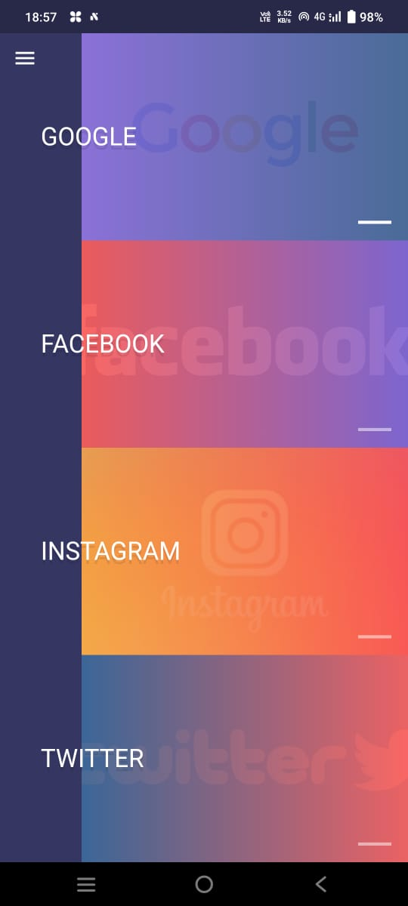

Google Page
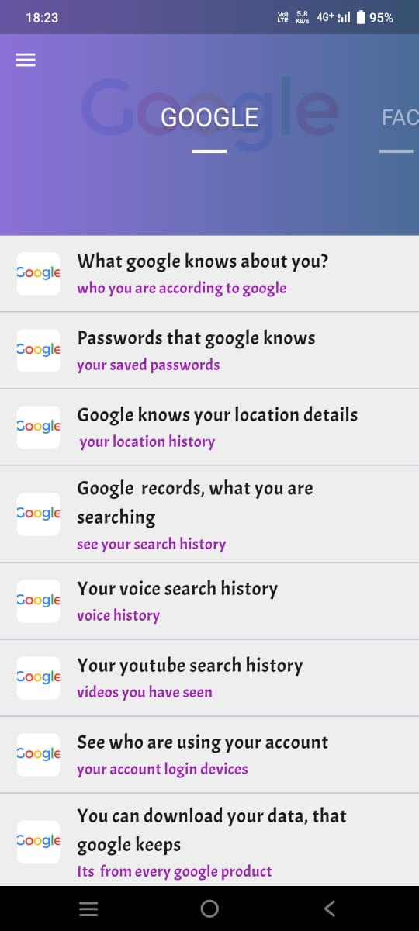

Facebook Page:
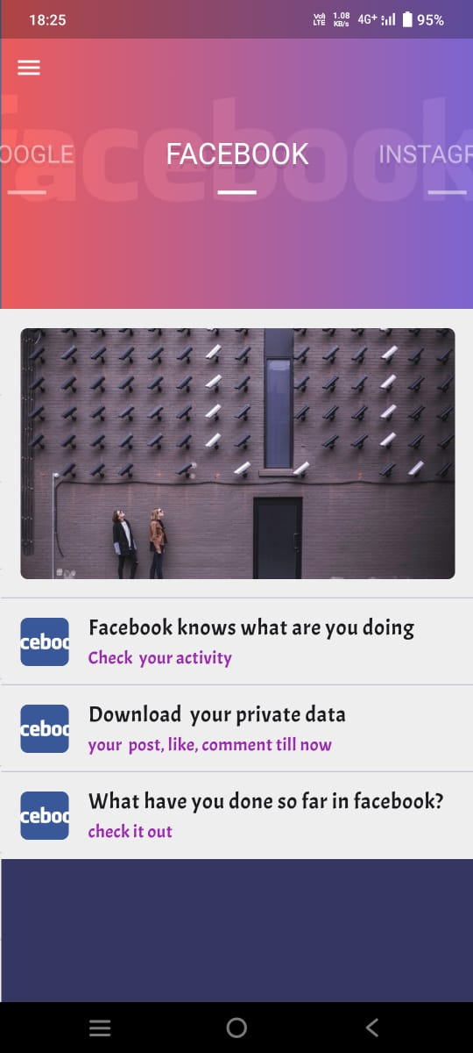

Instagram Page:
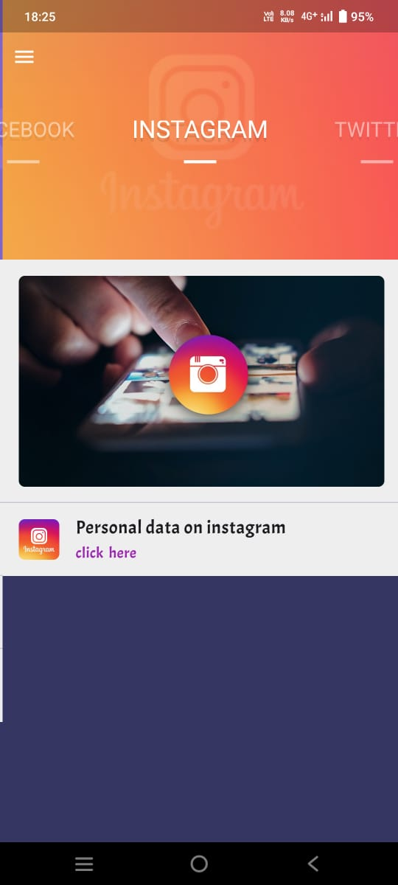

Dashboard:
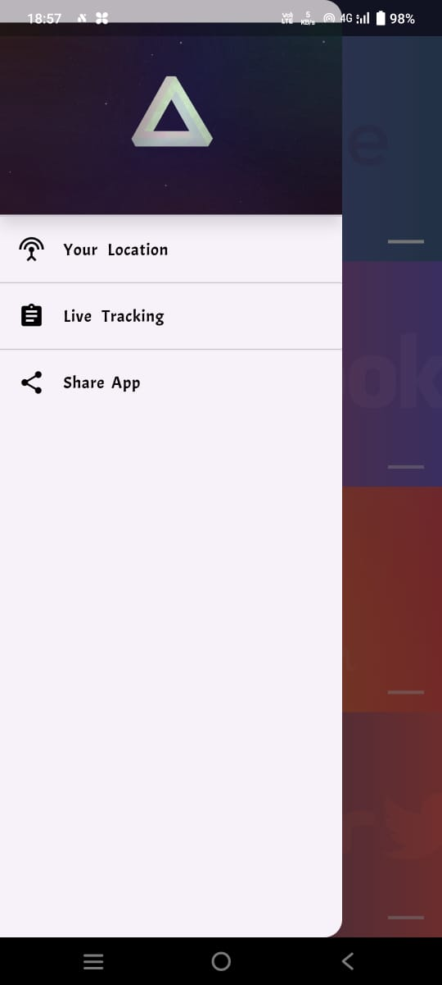

Location Page:
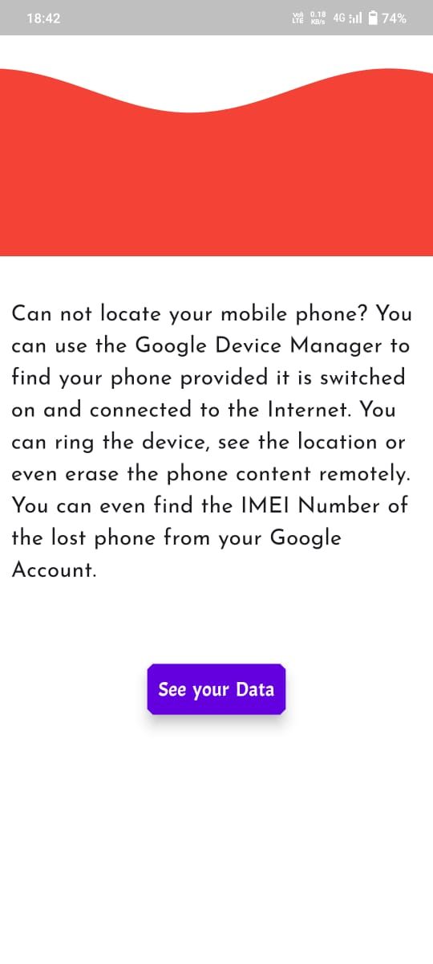

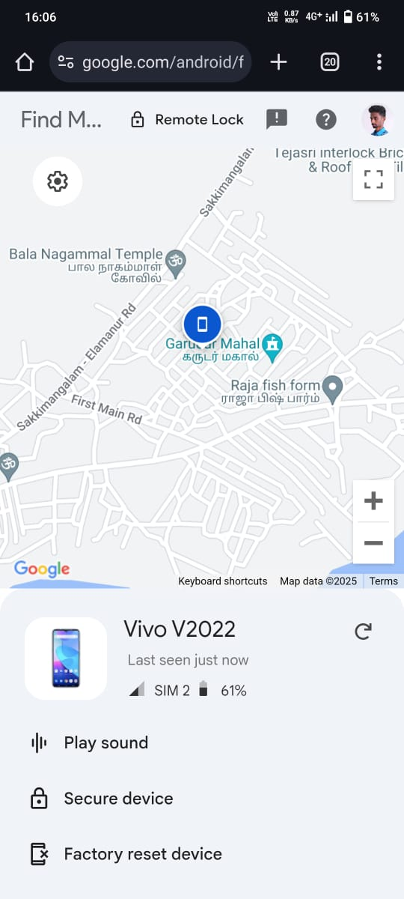

Activity Page:
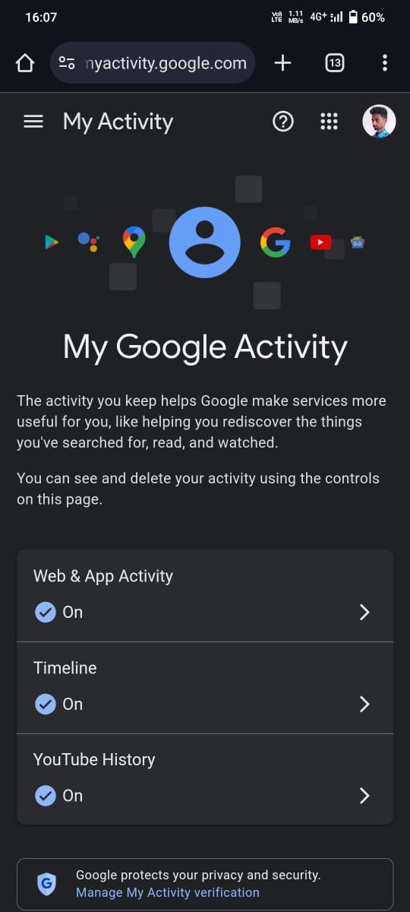

12. References & Bibliography
Books:
- "Flutter for Beginners" by Alessandro Biessek
- "Dart Programming: The Complete Guide" by Nathan Rozentals
- "Flutter Complete Reference" by Alberto Miola
- "Beginning Flutter: A Hands-On Guide to App Development" by Marco L. Napoli
- "Learning Dart" by Ivo Balbaert
- "Flutter for Beginners: An introductory guide to building cross-platform mobile applications with Flutter and Dart 2" by David O’Rourke
Websites:
- www. flutter.dev
- www. dart.dev
- www. flutterawesome.com
- www. flutterbyexample.com
- www. dartpad.dev
- www.freecodecamp.org
- www. stackoverflow.com

